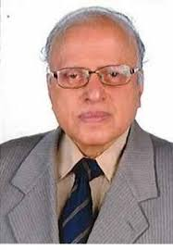

**Dr.M.S.Swaminathan,**

Father of Green Revolution,

Chairman of MS.Swaminathan Research Foundation (MSSRF).

Chennai.

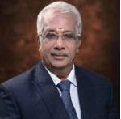

**Mr.Bimbadhar Pradhan,**

Special Secretary & Financial Advisor (DARE/ICAR)

New Delhi

**Dr.N.Kumar,**

Vice Chancellor,

Tamil Nadu Agricultural University,

Coimbatore,

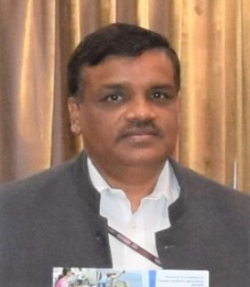

**Dr.K.Alagusundaram**

Deputy Director General (Agricultural Engineering)

Division of Agricultural Engineering,

New Delhi.

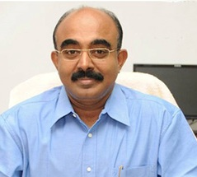

**Dr.K.Shanmugam,**

Chief Secretary to Government,

Finance Department,

Director of TN Industrial Development Corporation Limited

Chennai.

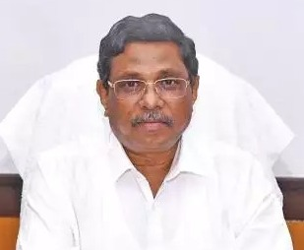

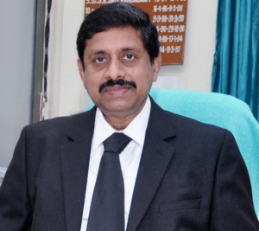

**Dr.M.Jawaharlal, Ph.D.,** Director of Extension Education

Tamil Nadu Agricultural University.

Coimbatore,

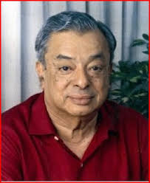

**Dr. Verghese Kurien,**

Father of White Revolution,

CO – Founder of ‘Amul’

Founder – NDDB

(National Dairy Development Board) & IRMA (Institute of Rural Management Anand)

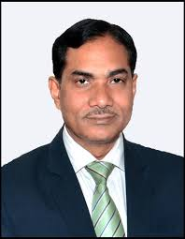

**Dr.Trilochan Mahopatra**

Director General of ICAR 2017,

New Delhi

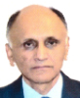

**Mr.Sanjay Kumar Singh**

Additional Secretary(DARE) & Secretary (ICAR),

New Delhi

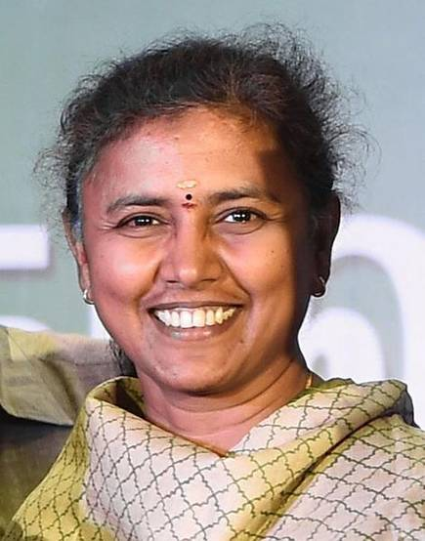

**Mrs.P.Amutha IAS,**

Joint Secretary in Prime Minister's Office (PMO),

New Delhi.

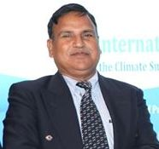

**Dr. M.Kalyanasundaram,**

Dean (Agriculture),

Agricultural College and Research Institute,

TNAU

**Dr.Narendra Pratap Singh,**

Director of Indian Institute of Pulses Research,

Kanpur.

Coimbatore,

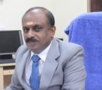

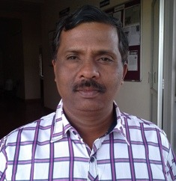

**Dr. L. Pugalendhi, Ph.D.,**

Dean (Horticulture),

Horticultural College and Research

Institute,

Coimbatore

Coimbatore,

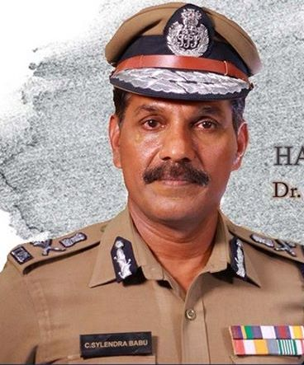

**Dr.C.Sylendra Babu IPS.,**

Additional Director General of police,

Chennai

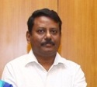

**Dr.P.Senthil Kumar IAS**

Principal Secretary III to Chief Secretary, Chennai,

Chennai of REPCO Bank.

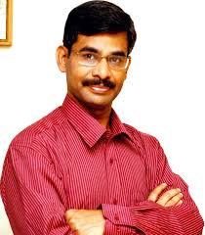

**Dr. V.Irai Anbu, I.A.S.,**  
Additional chief secretary to government  
Director, Anna Institute of Management &  
Director General of Training.

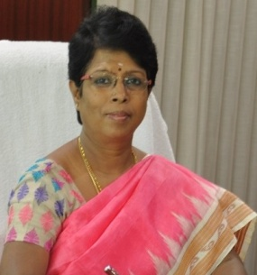

**Dr.S.Uma.,**

Director of National Banana Research Centre,

Trichy

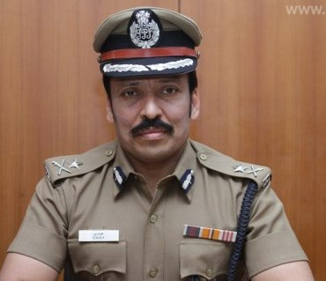

**Mr.M.Ravi.,**

Additional Director General of police ADGP (hqrs),

Chennai

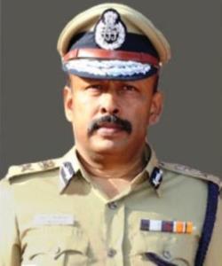

**Mr.K.P.Mahendran IPS.,**

DGP of police Training College,

Chennai

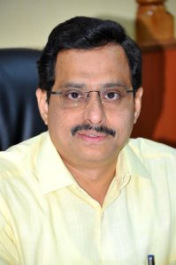

**Mr.S.A.Raman.,**

Collector,

Salem District.

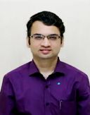

**Mr.Prashant M.Wadnere, I.A.S**.,

Collector and District Magistrate,

Kanyakumari District.

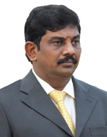

**Mr. C. Kathiravan, IAS,** Collector and District Magistrate,

Erode  District.

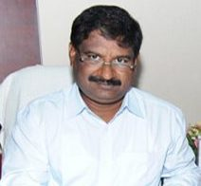

**Thiru S. Ganesh IAS.,**

Director,Indian Medicine and Homoeopathy, Arumbakkam, Chennai .

Former Collector of Pudukkottai District.

.

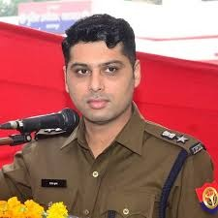

**Mr.P.Dinesh Kumar.,**

Senior Superintendent of Police,

Kanpur.

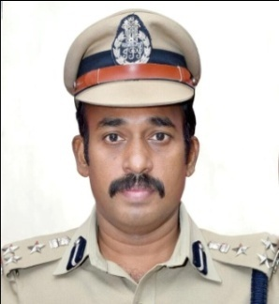

**Dr. J Loganathan.,**

Commissioner of Police, Trichy city.

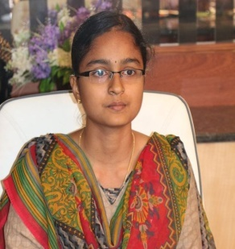

**Ms.Karthikeyyani Kanagaraj IFS,**

**IFS 2018 Topper,**

**UG in Agriculture**

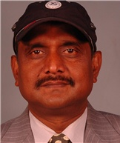

**Dr.R.R.B.Singh,**

Director of Dairy Research Institute.

Karnal.

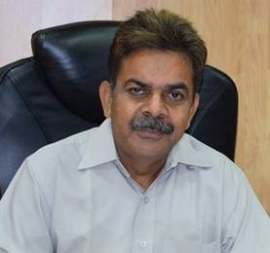

**Dr.A.D.Pathak,**

Director of Indian Institute of Sugarcane Lucknow.

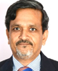

**Dr. A. K. Misra**,

Chairman ,

The Agricultural Scientists Recruitment Board,

New Delhi

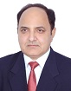

**Dr Tilak Raj Sharma,** Deputy Director General (Crop Science),

Division of Crop Science

New Delhi

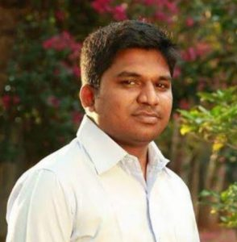

**Dr. T. Arumugam, Ph.D.,**

Dean,

Periyakulam

**Mr.V.P.Jeyaseelan, IAS**

Municipal Corporation Commissioner,

Thoothukudi City.

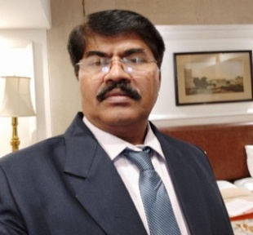

**Dr.K.Kranthi.,**

Former Director of Central Institute for Cotton Research, Maharastra,

Specialization in Entomolgy, IARI, Delhi

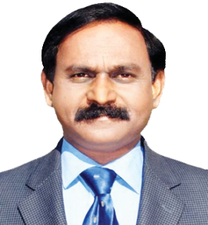

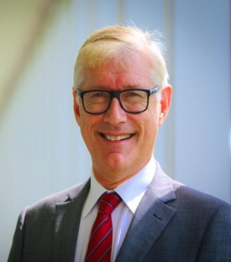

**Dr.Matthew Morrell,** Deputy Director General of IRRI,

Phillipines.

**Dr.R.R.B. Singh.,**

Director of Dairy Research Institute,

Karnal.

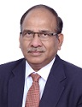

**Dr. R.C. Agarwal**

Deputy Director General (Agricultural Education)/ Act.

Division of Education

New Delhi



**Dr. A.K.Singh,**

Deputy Director General (Agricultural Extension)  
Division of Agricultural Extension

New Delhi

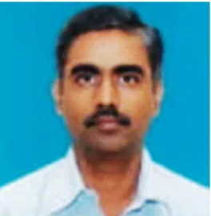

**Mr. V. Rajaraman IAS,** Chief Electoral Officer and Additional Secretary, Public (Electronics),

Tamil Nadu.

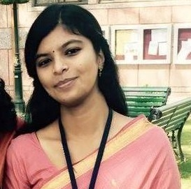

**Ms.Pallavi Sarkar**

Sub Divisional Officer (Civil),

Gossaigoan,

Assam